Piece-Reordering Rearrangement

Definition
# Source: AI Source: Provided by: [Data Path: Persons Table -> ID Column: 1, Name_En Column: Motasem Essam] -> From: [ChatGPT] on [7/25/2026]
Piece-Reordering Rearrangement is a type of geometric figure rearrangement in which the positions or sequence of individual pieces are changed to create a new configuration while preserving the shape and size of every piece.
The pieces may be moved to different locations or placed in a different order. Depending on the arrangement, pieces may also be rotated or reflected, but these additional transformations are not required for every piece-reordering rearrangement.

Simple Definition
# Source: AI Source: Provided by: [Data Path: Persons Table -> ID Column: 1, Name_En Column: Motasem Essam] -> From: [ChatGPT] on [7/25/2026]
Piece-reordering rearrangement means changing where the pieces are placed or the order in which they are arranged to create a new geometric figure.

Example
# Source: AI Source: Provided by: [Data Path: Persons Table -> ID Column: 1, Name_En Column: Motasem Essam] -> From: [ChatGPT] on [7/25/2026]
A square is divided into triangular pieces. The triangles are reordered and repositioned to form a parallelogram without changing the shape or size of any triangle.
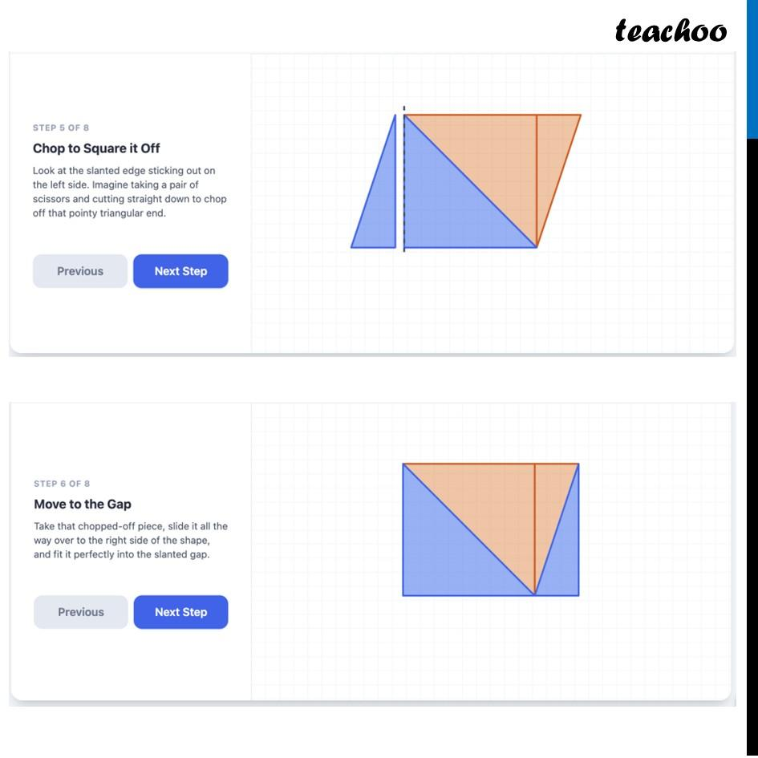

Main Classification of Piece-Reordering Rearrangement
# Source: AI Source: Provided by: [Data Path: Persons Table -> ID Column: 1, Name_En Column: Motasem Essam] -> From: [ChatGPT] on [7/25/2026]
The following is a practical classification based on how pieces are reordered. These categories may overlap and are not a universally standardized mathematical taxonomy.

1. Sequential Piece-Reordering Rearrangement
# Source: AI Source: Provided by: [Data Path: Persons Table -> ID Column: 1, Name_En Column: Motasem Essam] -> From: [ChatGPT] on [7/25/2026]
Pieces are rearranged in a different sequence or order to create a new configuration.
Example: Three triangular pieces originally arranged from left to right are reordered so that a different triangle appears first and the pieces form a new polygon.
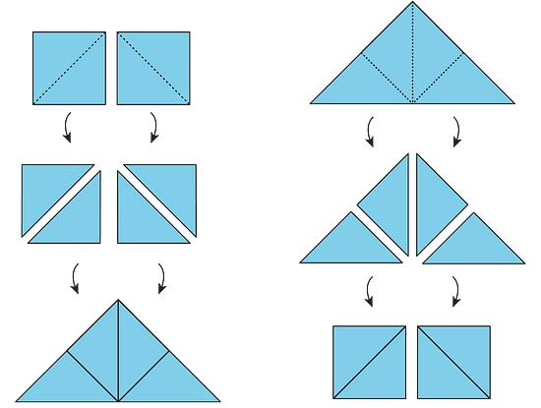

2. Positional Piece-Reordering Rearrangement
# Source: AI Source: Provided by: [Data Path: Persons Table -> ID Column: 1, Name_En Column: Motasem Essam] -> From: [ChatGPT] on [7/25/2026]
Pieces are moved to different positions within the overall arrangement while retaining their individual shapes and sizes.
Example: Two triangular pieces are moved from the top of a square-shaped arrangement to the bottom to create a new outline.
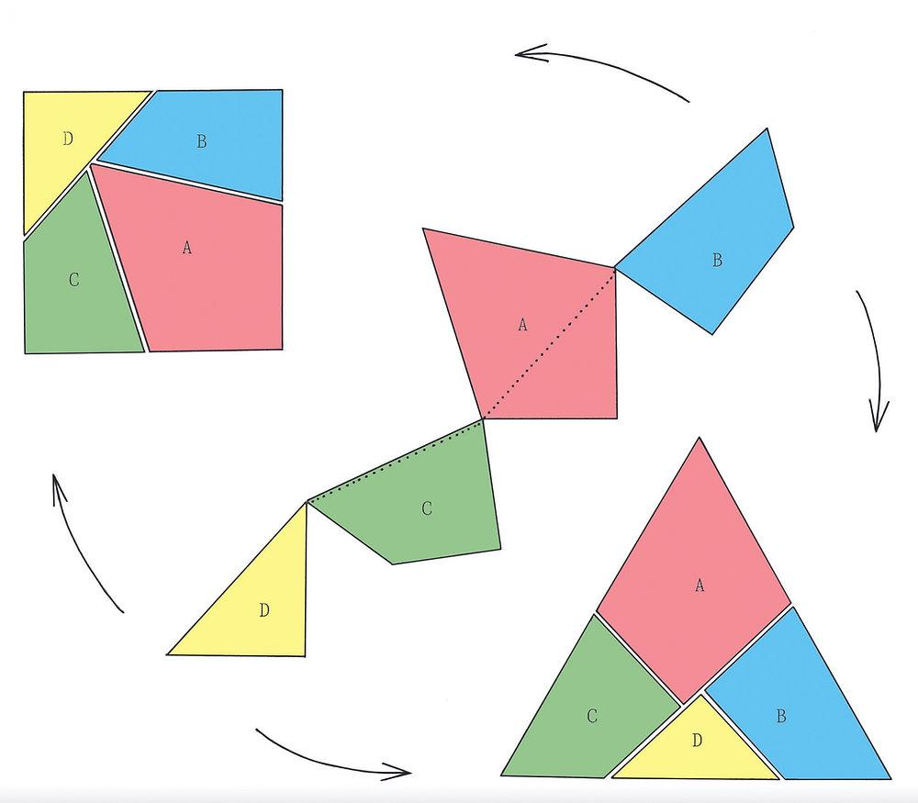

3. Adjacency-Based Piece-Reordering Rearrangement
# Source: AI Source: Provided by: [Data Path: Persons Table -> ID Column: 1, Name_En Column: Motasem Essam] -> From: [ChatGPT] on [7/25/2026]
Pieces are reordered so that different edges become adjacent or previously adjacent pieces become separated.
Example: Two triangular pieces that originally touch along one edge are repositioned so that each touches a different piece, forming a new polygon.
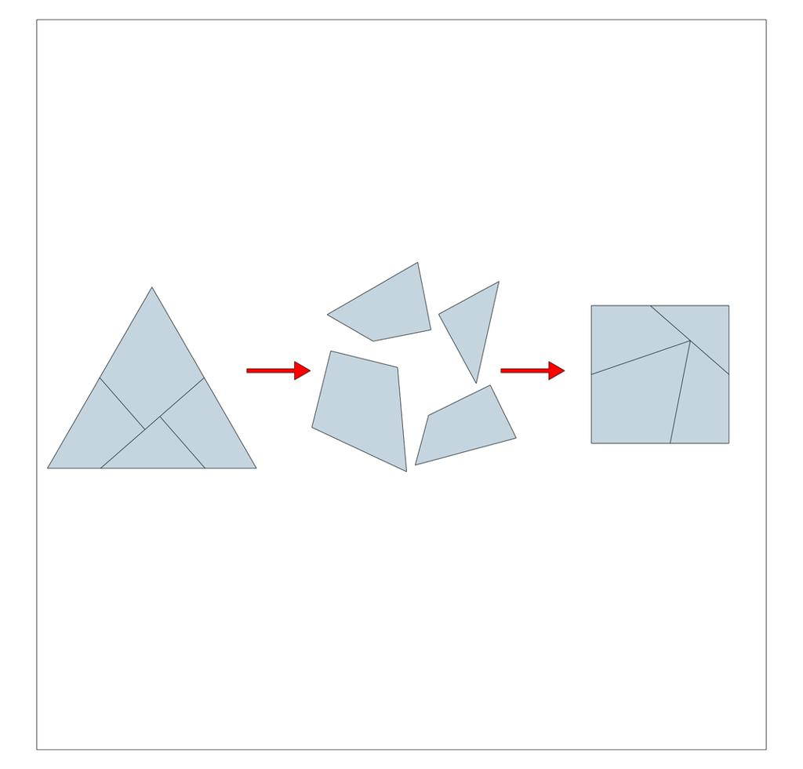

4. Boundary-Based Piece-Reordering Rearrangement
# Source: AI Source: Provided by: [Data Path: Persons Table -> ID Column: 1, Name_En Column: Motasem Essam] -> From: [ChatGPT] on [7/25/2026]
Pieces are reordered to change the outer boundary or silhouette of the combined figure.
Example: Triangular pieces forming a square are rearranged to create a parallelogram with a different outer boundary.
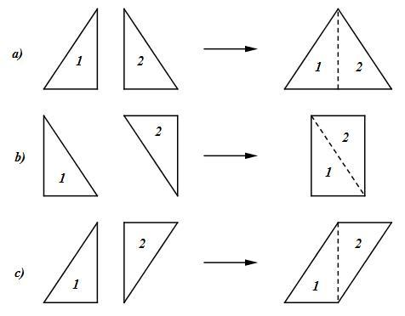

5. Row-Based Piece-Reordering Rearrangement
# Source: AI Source: Provided by: [Data Path: Persons Table -> ID Column: 1, Name_En Column: Motasem Essam] -> From: [ChatGPT] on [7/25/2026]
Pieces are reordered into different rows or horizontal layers.
Example: Four triangular pieces initially arranged in one compact pattern are reorganized into two rows to form a larger rectangular arrangement.
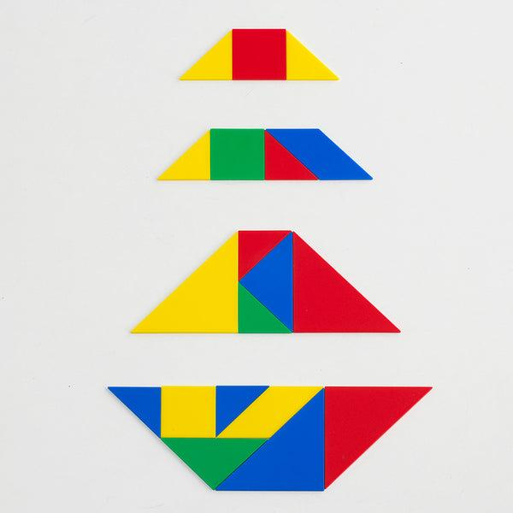

6. Grid-Based Piece-Reordering Rearrangement
# Source: AI Source: Provided by: [Data Path: Persons Table -> ID Column: 1, Name_En Column: Motasem Essam] -> From: [ChatGPT] on [7/25/2026]
Pieces are reordered according to positions on a grid, often to form a regular or easily measured arrangement.
Example: Square pieces are moved from a single row into a two-by-two grid to create a larger square.
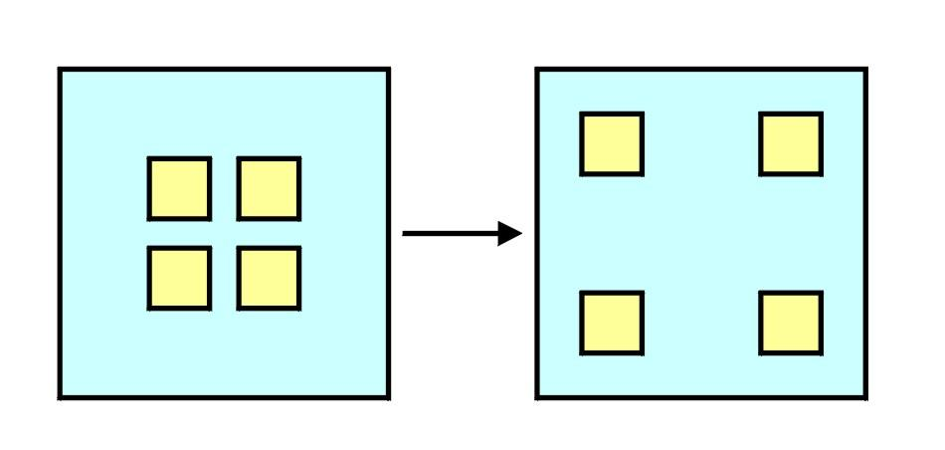

7. Symmetry-Based Piece-Reordering Rearrangement
# Source: AI Source: Provided by: [Data Path: Persons Table -> ID Column: 1, Name_En Column: Motasem Essam] -> From: [ChatGPT] on [7/25/2026]
Pieces are reordered to create or improve a symmetrical arrangement.
Example: Two matching triangular pieces are placed on opposite sides of a central line, creating a symmetrical diamond-shaped figure.
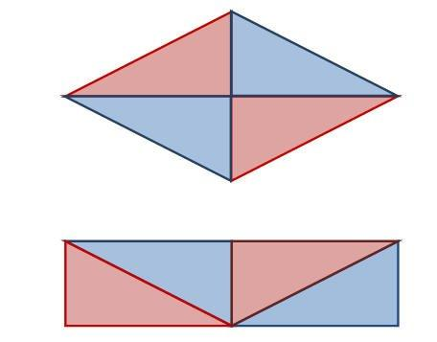

8. Pattern-Based Piece-Reordering Rearrangement
# Source: AI Source: Provided by: [Data Path: Persons Table -> ID Column: 1, Name_En Column: Motasem Essam] -> From: [ChatGPT] on [7/25/2026]
Pieces are reordered to create a repeated or visually structured pattern.
Example: Identical triangular tiles are reordered to form a repeating sequence of diamonds or zigzag shapes.
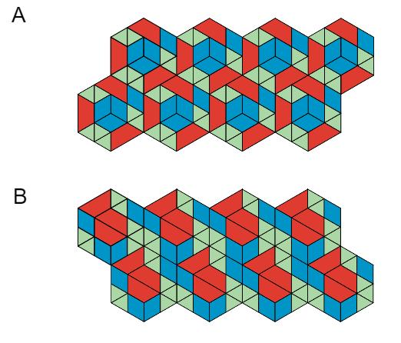

Mathematical Representation
# Source: AI Source: Provided by: [Data Path: Persons Table -> ID Column: 1, Name_En Column: Motasem Essam] -> From: [ChatGPT] on [7/25/2026]
Suppose a geometric figure $F$ consists of $n$ individual pieces:
$$F=P_{1}∪P_{2}∪⋯∪P_{n}$$
Piece-reordering rearranges the positions or order of these pieces to create a new figure $F'$:
$$F'=P'_{1}∪P'_{2}∪⋯∪P'_{n}$$
Each piece retains its original shape and size. If the pieces cover the resulting figure without gaps or overlaps, the total area is preserved:
$$\boxed{A\left(F'\right)=A\left(F\right)}$$
This area equality assumes that the original and final figures consist of the same pieces, with no material added or removed.

Detailed Mathematical Example
# Source: AI Source: Provided by: [Data Path: Persons Table -> ID Column: 1, Name_En Column: Motasem Essam] -> From: [ChatGPT] on [7/25/2026]
Consider a square divided into four congruent right-triangular pieces. The pieces are reordered to form a parallelogram.
Suppose each triangle has perpendicular side lengths $3$ units and $4$ units.
The area of one triangle is:
$$A=\frac{1}{2}bh=\frac{1}{2}\left(3\right)\left(4\right)=6$$
The total area of the four triangles is:
$$A_{\text{total}}=4\left(6\right)=24$$
After reordering the pieces into a parallelogram, the area remains:
$$\boxed{A_{\text{parallelogram}}=24}$$
The outer boundary changes, but the four individual triangular pieces retain their shapes, dimensions, and areas.

Properties of Piece-Reordering Rearrangement
# Source: AI Source: Provided by: [Data Path: Persons Table -> ID Column: 1, Name_En Column: Motasem Essam] -> From: [ChatGPT] on [7/25/2026]
- Piece preservation: The same individual pieces are used before and after rearrangement.
- Shape preservation: Each piece retains its shape.
- Size preservation: Each piece retains its dimensions.
- Area preservation: The total area remains unchanged when the pieces are assembled without gaps or overlaps.
- Position change: Individual pieces may occupy different locations.
- Adjacency change: Pieces may touch different neighboring pieces.
- Boundary change: The combined figure may have a different outer shape and perimeter.
- Transformation flexibility: Translation, rotation, or reflection may be used when needed, but none is required merely by the definition of reordering.

Piece-Reordering Rearrangement vs. Other Types
# Source: AI Source: Provided by: [Data Path: Persons Table -> ID Column: 1, Name_En Column: Motasem Essam] -> From: [ChatGPT] on [7/25/2026]
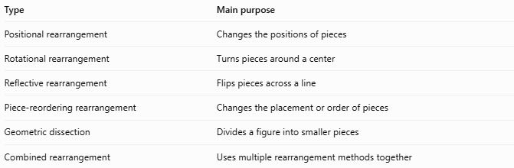
Type | Main purpose
Positional rearrangement | Changes the positions of pieces
Rotational rearrangement | Turns pieces around a center
Reflective rearrangement | Flips pieces across a line
Piece-reordering rearrangement | Changes the placement or order of pieces
Geometric dissection | Divides a figure into smaller pieces
Combined rearrangement | Uses multiple rearrangement methods together
Important distinction: These categories can overlap. For example, reordering triangular pieces may also require translating and rotating them. Piece-reordering focuses on how the pieces are reorganized, rather than on one particular geometric transformation.

Classification Summary
# Source: AI Source: Provided by: [Data Path: Persons Table -> ID Column: 1, Name_En Column: Motasem Essam] -> From: [ChatGPT] on [7/25/2026]
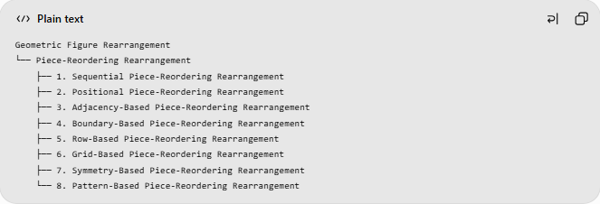
Geometric Figure Rearrangement
└── Piece-Reordering Rearrangement
├── 1. Sequential Piece-Reordering Rearrangement
├── 2. Positional Piece-Reordering Rearrangement
├── 3. Adjacency-Based Piece-Reordering Rearrangement
├── 4. Boundary-Based Piece-Reordering Rearrangement
├── 5. Row-Based Piece-Reordering Rearrangement
├── 6. Grid-Based Piece-Reordering Rearrangement
├── 7. Symmetry-Based Piece-Reordering Rearrangement
└── 8. Pattern-Based Piece-Reordering Rearrangement
This is a practical, descriptive classification. The categories are not necessarily mutually exclusive or formally standardized.

Key Points
# Source: AI Source: Provided by: [Data Path: Persons Table -> ID Column: 1, Name_En Column: Motasem Essam] -> From: [ChatGPT] on [7/25/2026]
- Piece-reordering rearrangement changes the arrangement of pieces without changing their individual shapes or sizes.
- It can produce a new overall figure from the same collection of pieces.
- The total area is preserved when the pieces are assembled without gaps or overlaps.
- The outer boundary, perimeter, and adjacency relationships may change.
- Translation, rotation, and reflection can be combined with reordering when necessary.

Conclusion
# Source: AI Source: Provided by: [Data Path: Persons Table -> ID Column: 1, Name_En Column: Motasem Essam] -> From: [ChatGPT] on [7/25/2026]
Piece-Reordering Rearrangement is a geometric method of creating a new figure by changing the positions or order of its constituent pieces while preserving each piece's shape and size. It is useful in geometric dissection, tangram puzzles, tiling, area demonstrations, and geometric problem-solving.

